Phenol (Natural Refined)
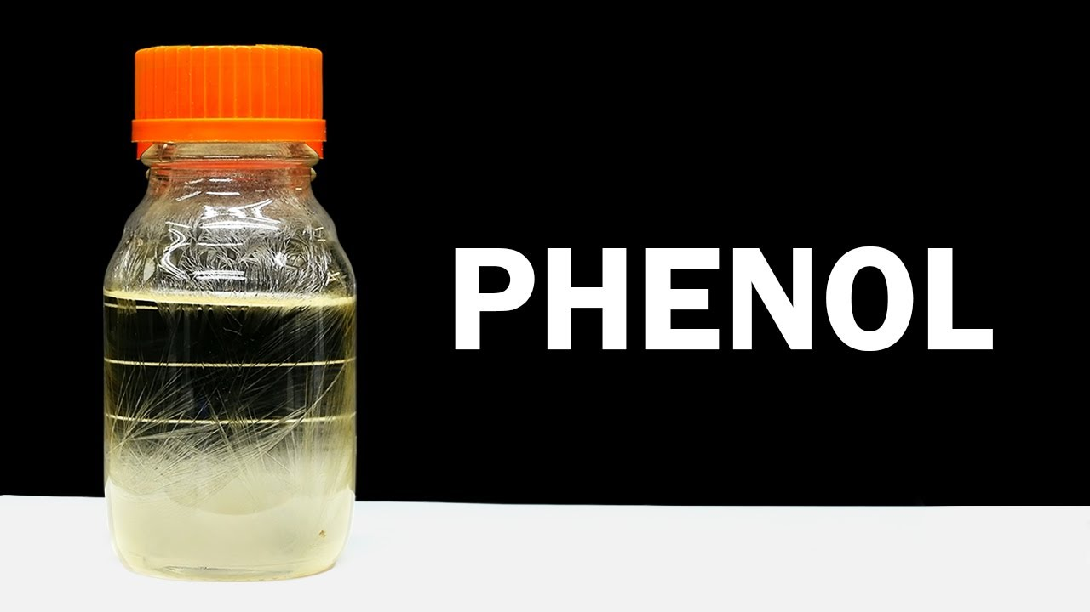
A product of Dakota Gasification Company

Typical Results (Results are an average of 79 railcars loaded November 2023 – November 2024)

Parameter Units Typical Result
Moisture | Wt% | .02
Neutral Oils | Wt% | 0.016
Ortho Cresol | Wt% | .004
Color | APHA | 3
Freeze Point (Dry) | Degrees C | 40.8
Purity (dry basis) | Wt% | 99.9
